ISTITUTO COMPRENSIVO “G. GALILEI – PASCOLI”
Scuola Secondaria di primo grado “ Galileo-Galilei“, Reggio Calabria
Nombre ..............................................  Apellido .............................................  Clase .................................................  Fecha ................................................. | COMPITO DI REALTÀ PER LA CERTIFICAZIONE DELLE COMPETENZE (LINGUA SPAGNOLA)  CLASSI SECONDE - PRIMO QUADRIMESTRE
ESCRITURA | COMIDAS
Obiettivo: il vostro compito è descrivere le personali abitudini alimentari.
Prodotto: preparare in forma cartacea una lista di cibi e bevande – descrivere i pasti principali.
Standard di successo: correttezza grammaticale, spelling e vocabolario.

Completa el cuadro con los cinco grupo de los alimentos.

Frutas y verduras | Cereales, derivados y tubérculos | Leche y derivados | Carne, pescado, huevos y legumbres | Grasas y azúcares
________________________________________________________________________________________________________________________________________________________________________ | ________________________________________________________________________________________________________________________________________________________________________ | ________________________________________________________________________________________________________________________________________________________________________ | ________________________________________________________________________________________________________________________________________________________________________ | ________________________________________________________________________________________________________________________________________________________________________

- ¿Qué tomas normalmente de desayuno?
____________________________________________________________________________________________________________________________________________________________________________

- ¿Qué tomas normalmente de almuerzo?
____________________________________________________________________________________________________________________________________________________________________________

- ¿Qué tomas normalmente de cena?
____________________________________________________________________________________________________________________________________________________________________________

- ¿Qué platos típicos de España o Hispanoamérica conoces?
____________________________________________________________________________________________________________________________________________________________________________

PUNTEGGIO TOTALE: / 20
ISTITUTO COMPRENSIVO “G. GALILEI – PASCOLI”
Scuola Secondaria di primo grado “ Galileo-Galilei“, Reggio Calabria
Nombre ..............................................  Apellido .............................................  Clase .................................................  Fecha ................................................. | COMPITO DI REALTÀ PER LA CERTIFICAZIONE DELLE COMPETENZE (LINGUA SPAGNOLA)  CLASSI SECONDE - SECONDO QUADRIMESTRE
ESCRITURA | DESCRIPCIÓN DE ESPAÑA
Obiettivo: il vostro compito è descrivere geograficamente la Spagna.
Prodotto: partendo dalla cartina geografica della Spagna, individuare le aree da visitare (città, laghi, catene montuose, isole, fiumi, pianure, etc), facendo anche riferimento alle tradizioni spagnole.
Standard di successo: correttezza grammaticale, spelling e vocabolario.

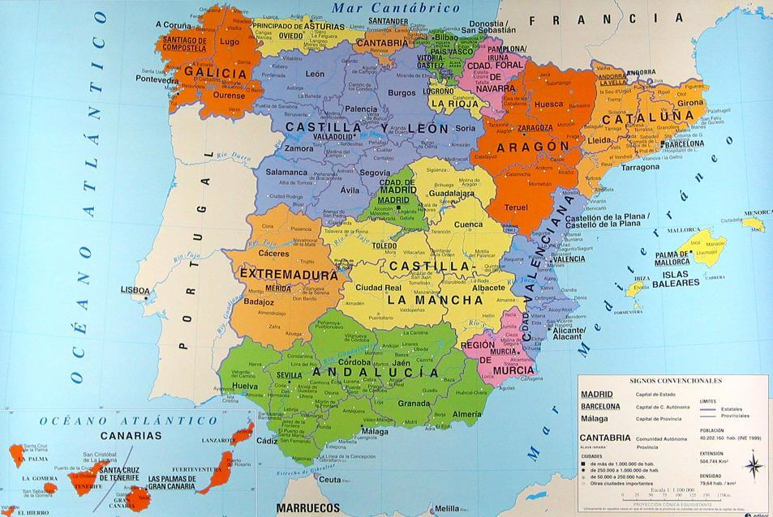

Describe la España.
_______________________________________________________________________________________
_______________________________________________________________________________________
_______________________________________________________________________________________
_______________________________________________________________________________________
_______________________________________________________________________________________
_______________________________________________________________________________________
_______________________________________________________________________________________
_______________________________________________________________________________________
_______________________________________________________________________________________

1. ¿Cuántas lenguas se hablan en España y dónde?
_______________________________________________________________________________________
_______________________________________________________________________________________
_______________________________________________________________________________________
_______________________________________________________________________________________

2.¿Cuáles son los sitios más interesantes que tiene que ver quién va a visitar Barcelona?
_______________________________________________________________________________________
_______________________________________________________________________________________
_______________________________________________________________________________________
_______________________________________________________________________________________

3.¿Cuál es la capital de Galicia? ¿Qué es el Camino de Santiago?
_______________________________________________________________________________________
_______________________________________________________________________________________
_______________________________________________________________________________________
_______________________________________________________________________________________

4. ¿Dónde se celebra la fiesta de San Fermín y por qué es muy conocida?
_______________________________________________________________________________________
_______________________________________________________________________________________
_______________________________________________________________________________________
_______________________________________________________________________________________

PUNTEGGIO TOTALE: / 20

