ISTITUTO COMPRENSIVO “G. GALILEI – PASCOLI”
Scuola Secondaria di primo grado “ Galileo-Galilei“, Reggio Calabria
Name..................................................  Surname ….........................................  Class …...............................................  Date …................................................. | COMPITO DI REALTÀ PER LA CERTIFICAZIONE DELLE COMPETENZE (LINGUA INGLESE)  CLASSI SECONDE - PRIMO QUADRIMESTRE
WRITING | MEALS
Obiettivo : Il vostro compito è descrivere le personali abitudini alimentari
Prodotto : Preparare in forma cartacea una lista di almeno 10 nomi di cibi e bevande – Descrivere i pasti principali
Standard di successo : - correttezza grammaticale, spelling e vocabulary.
(uso countable/uncountable – some/any – a/an – plural of nouns – Present Simple)

Make a list of 10 countable /uncountable food  Use a/an/some  Example: a croissant- some fruit |  | Make a list of Drinks  Use Containers  Example : a can of beer
 |  | A can of
 |  | A glass of
 |  | A cup of
 |  | A mug of
 |  | A bottle of
- What do you usually have at Breakfast?
____________________________________________________________________________________________________________________________________________________________________________

- What do you usually have at Lunch?
____________________________________________________________________________________________________________________________________________________________________________

- What do you uusually have at dinner?
____________________________________________________________________________________________________________________________________________________________________________

- What is the typical British breakfast?
__________________________________________________________________________________________________________________________________________________________________________________________________________________________________________________________________
PUNTEGGIO TOTALE: /20
ISTITUTO COMPRENSIVO “G. GALILEI – PASCOLI”
Scuola Secondaria di primo grado “ Galileo-Galilei“, Reggio Calabria
Name..................................................  Surname ….........................................  Class …...............................................  Date …................................................. | COMPITO DI REALTÀ PER LA CERTIFICAZIONE DELLE COMPETENZE (LINGUA INGLESE)  CLASSI SECONDE - SECONDO QUADRIMESTRE
WRITING | Write an itinerary on the UK
Obiettivo : Il vostro compito è creare un itinerario di scoperta dei siti più suggestivi di ciascuna regione del Regno Unito.
Prodotto : Partendo dalla cartina geografica del Regno Unito, individuare sulla mappa i luoghi da visitare (parchi, laghi, scogliere, catene montuose, castelli, fiumi, monumenti ,etc) per ciascuna regione del Regno Unito. Tracciare un itinerario per ciascuna area.
Standard di successo : - correttezza grammaticale, spelling e vocabulary.

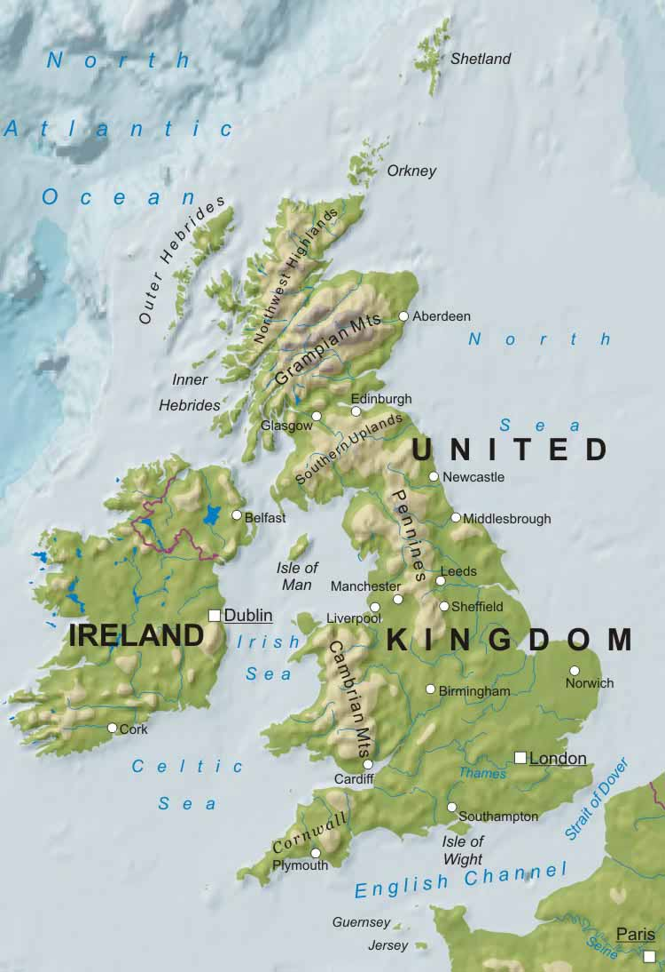

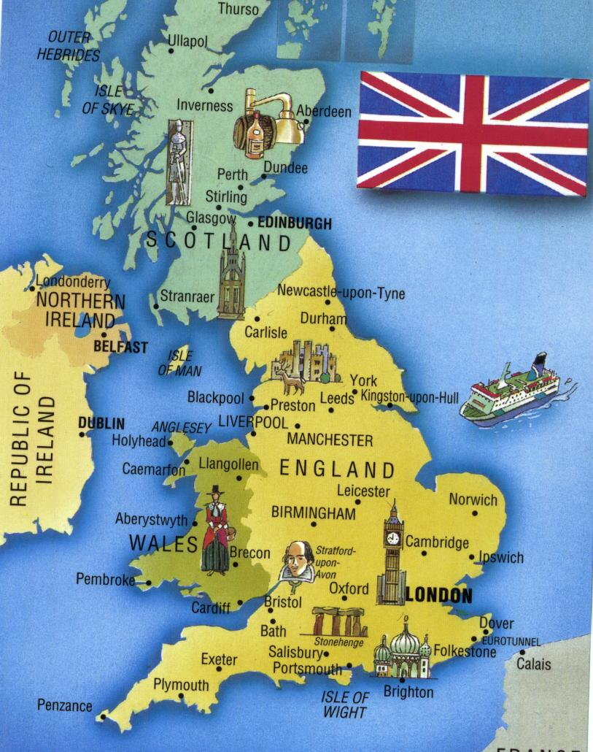 | The Uk is made up of_________________________  ________________________________________________________________________________________________________________________________________________________________________________MY UK ITINERARY  ____________________________________________________________________________________________________________________________________________________________________________________________________________________________________________________________________________________________________________________________________________________________________________________________________________
1. What are the most amazing natural areas and places of interest to see in England?
______________________________________________________________________________________________________________________________________________________________________________________________________________________________________________________________________________________________________________________________________________________________________________________________________________________________________________
2. What are the most amazing natural areas and places of interest to see in Scotland?
______________________________________________________________________________________________________________________________________________________________________________________________________________________________________________________________________________________________________________________________________________________________________________________________________________________________________________
3.What are the most amazing natural areas and places of interest to see in Wales?
______________________________________________________________________________________________________________________________________________________________________________________________________________________________________________________________________________________________________________________________________________________________________________________________________________________________________________
4.What are the most amazing natural areas and places of interest to see in Northern Ireland?
_____________________________________________________________________________________
________________________________________________________________________________________________________________________________________________________________________________________________________________________________________________________________________________________________________________________________________________________

PUNTEGGIO TOTALE: /20

